What impact did World War II have upon America?
E | S | P
 |  | 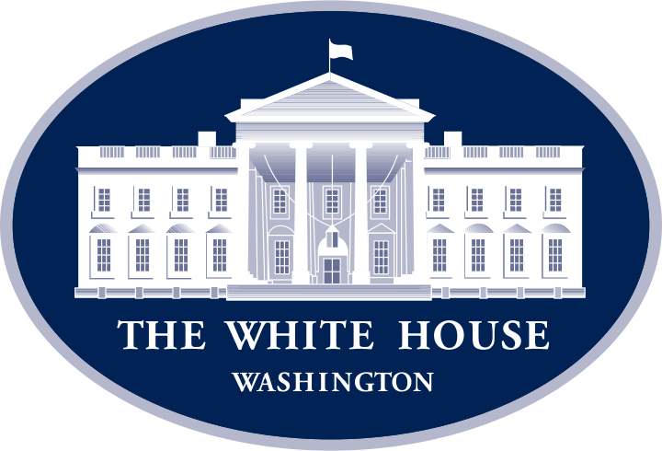

Economically, Socially & Politically
WWII broke out in 1939. USA did not enter until 1941. However, from 1939 USA supplied European countries fighting in the war with food and other goods. After 1941, the US focused upon the war effort, both industry and agriculture concentrated upon producing goods for the war. Car manufacturer, General Motors, produced heavy machine guns. Conscription was introduced and 15 million men and women joined the armed forces. On the home front, millions of men and women worked in munitions factories and unemployment levels dropped dramatically. Companies began making huge profits. The war pulled the US out of the Depression. By the end of WWII, the USA had a huge army and was producing almost half the weapons in the world. Women had made significant gains in employment.
Read through the passage above and then change the sentences into pictures that resemble the words. You can only use a maximum of 10 words to help develop your work. Once you have completed your drawings add and E, S or P to the parts you feel have and economic, social or political impact.

